Braille-Based IoT Home Automation for Multi-Disability Empowerment

A Project Report

Submitted to the FACULTY of ENGINEERING of

JAWAHARLAL NEHRU TECHNOLOGICAL UNIVERSITY, KAKINADA
In partial fulfillment of the requirements,
for the award of the Degree of

Bachelor of Technology
In

Electronics and Communication Engineering
By
N. Manikanta Raghava  (23485A0424) | M.Jahnavi  (22481A04F5)
N.Venkata Siva Prasanth  (23485A0423) | Md.Habeeb Pasha  (22481A04F8)
Under the Guidance of
Mr.V.Vittal Reddy

(Associate Professor)
Department of Electronics and Communication Engineering
SESHADRI RAO GUDLAVALLERU ENGINEERING COLLEGE
(An Autonomous Institute with Permanent Affiliation to JNTUK, Kakinada) SESHADRI RAO KNOWLEDGE VILLAGE
GUDLAVALLERU - 521356 ANDHRA PRADESH
2025-2026

Braille-Based IoT Home Automation for Multi-Disability Empowerment

A Project Report

Submitted to the FACULTY of ENGINEERING of

JAWAHARLAL NEHRU TECHNOLOGICAL UNIVERSITY, KAKINADA
In partial fulfillment of the requirements,
for the award of the Degree of

Bachelor of Technology
In

Electronics and Communication Engineering
By
N. Manikanta Raghava  (23485A0424) | M.Jahnavi  (22481A04F5)
N.Venkata Siva Prasanth  (23485A0423) | Md.Habeeb Pasha  (22481A04F8)
Under the Guidance of
Mr.V.Vittal Reddy

(Associate Professor)
Department of Electronics and Communication Engineering
SESHADRI RAO GUDLAVALLERU ENGINEERING COLLEGE
(An Autonomous Institute with Permanent Affiliation to JNTUK, Kakinada) SESHADRI RAO KNOWLEDGE VILLAGE
GUDLAVALLERU - 521356 ANDHRA PRADESH
2025-2026

Department of Electronics and Communication Engineering
SESHADRI RAO GUDLAVALLERU ENGINEERING COLLEGE
(An Autonomous Institute with Permanent Affiliation to JNTUK, Kakinada)
SESHADRI RAO KNOWLEDGE VILLAGE
GUDLAVALLERU – 521356
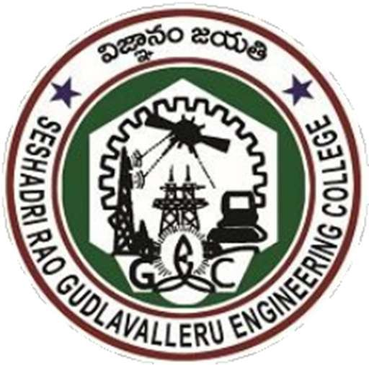

CERTIFICATE

This is to certify that project report entitled “Braille-Based IoT Home Automation for Multi-Disability Empowerment” is a bonafide record of work carried out by N.Manikanta Raghava (23485A0424),M.Jahnavi (22481A04F5), N.Venkata Siva Prasanth (23485A0423), Md.Habeeb Pasha (22481A04F8) under my guidance and supervision in partial fulfillment of the requirements for the award of the degree of Bachelor of Technology in Electronics and Communication Engineering of Seshadri Rao Gudlavalleru Engineering College Affiliated to Jawaharlal Nehru Technological University, Kakinada.

Mr.V.Vittal Reddy | Dr. B. Rajasekhar
Project guide | Head of the Department

Acknowledgement

We are very glad to express our deep sense of gratitude to Mr. V. Vittal Reddy, Associate professor, Electronics and Communication Engineering Department, for his guidance and cooperation for completing this project. We convey our heartfelt thanks to him for his inspiring assistance till the end of our project.
We convey our sincere and indebted thanks to our beloved Head of the Department Dr. B. Rajasekhar, for his encouragement and help for completing our project successfully.
We also extend our gratitude to our principal Dr. B. Karuna Kumar, for the support and for providing facilities required for the completion of our project.
We impart our heartfelt gratitude to all the Lab Technicians for helping us in all aspects related to our project.
We thank our friends and all others who rendered their help directly and indirectly to complete our project.

N. Manikanta Raghava | (23485A0424)
M.Jahnavi | (22481A04F5)
N.Venkata Siva Prasanth | (23485A0423)
Md.Habeeb Pasha | (22481A04F8)

